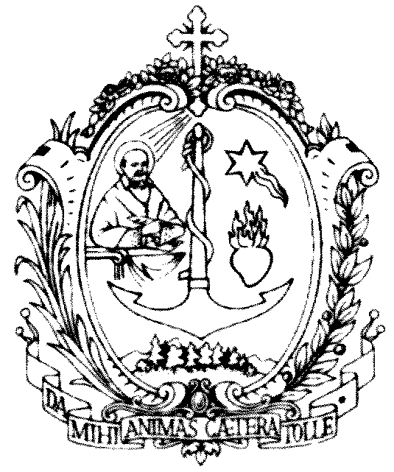
SOCIETA’ DI SAN FRANCESCO DI SALES
sede centrale salesiana
Via Marsala 42 - 00185 Roma
Il Postulatore Generale per le Cause dei Santi

INTERVENTION ON THE SPIRITUALITY DAYS OF THE SALESIAN FAMILY 2021

IN THE LIGHT OF THE STRENNA

This year's Strenna "Do everything for love, nothing necessarily", dedicated to Saint Francis de Sales on the 4th centenary of his death is a great gift for the whole Salesian Family. Don Bosco "chose him as inspirer and patron as he proposed, with his work and his writings, that Christian humanism and that methodology of charity that well corresponded to his intimate aspirations. It is a humanism that does not ignore man's weakness, but is based on unshakable trust in the intrinsic goodness of the person, because he is loved by God and called by him to Christian perfection, in every form of life. This humanism is a constitutive aspect of the charismatic and spiritual experience of the Groups founded by Don Bosco and was made their own, as a precious inheritance, by the other Groups today aggregated to the one Family. The whole Salesian Family is therefore part of this great current, offering the Church an original contribution in the field of education and apostolic work (Identity Card of the Salesian Family of Don Bosco n. 7).

From his person and from his doctrine emanate an impression of rare fullness, demonstrated in the serenity of his intellectual research, but also in the richness of his affections, in the "sweetness" of his teachings which had a great influence on the Christian conscience. Certainly our path of holiness and the promotion of the causes of beatification and canonization of our Salesian Family draw from him great inspiration and strong motivation.

Being completely of God, living His presence in the world to the full

This is probably the most "revolutionary" proposal of St. Francis de Sales. Pope Emeritus Benedict XVI expressed it with his usual depth and beauty when he said that the great invitation that St. Francis de Sales addresses to Christians is that of "being completely of God, living fully the presence in the world and the tasks of one's own state . “My intention is to educate those who live in the cities, in the marital state, at the court […]” (Preface to the Introduction to the Devout Life). The Document with which Pope Pius IX, more than two centuries later, proclaimed him a Doctor of the Church will insist on this broadening of the call to perfection, to holiness. It is written: "[true piety] has penetrated to the throne of kings, into the tent of the chiefs of armies, into the praetorium of judges, into the offices, into the shops and even into the shepherds' huts [...]" (Breve Dives in misericordia, November 16, 1877). Thus was born that appeal to the laity, that care for the consecration of temporal things and for the sanctification of everyday life on which the Second Vatican Council and the spirituality of our time will insist. The ideal of a reconciled humanity was manifested, in the harmony between action in the world and prayer, between the secular condition and the search for perfection, with the help of the Grace of God that permeates the human and, without destroying it, purifies it, elevating it. to divine heights "(Benedict XVI, General Audience of March 2, 2011).

Pope Francis in the exhortation Gaudete et Exsultate on the Call to Holiness in the contemporary world also tells us: "Many times we are tempted to think that holiness is reserved for those who have the opportunity to keep their distance from ordinary occupations, to devote a lot of time to prayer. It is not so. We are all called to be saints by living with love and each offering his own testimony in the occupations of every day, wherever he is. Are you a consecrated woman or a consecrated person? Be holy by living your donation with joy. You are married? Be holy by loving and caring for your husband or wife, as Christ did with the Church. Are you a worker? Be holy by carrying out your work in the service of the brothers with honesty and competence. Are you a parent or grandmother or grandfather? Be holy by patiently teaching children to follow Jesus. Do you have authority? Be holy by fighting for the common good and giving up your personal interests. Let the grace of your Baptism bear fruit on a journey of holiness. Let everything be open to God and to this end choose Him, choose God always anew. Do not be discouraged, because you have the strength of the Holy Spirit to make it possible, and holiness, after all, is the fruit of the Holy Spirit in your life (cf. Gal 5: 22-23) ". (GE nn. 14-15).

From Don Bosco to our days, a tradition of holiness is attested to which deserves attention, because it is the incarnation of the charism that originated from him and which is expressed in a plurality of states of life and forms. These are men and women, young people and adults, consecrated and lay people, bishops and missionaries who in historical, cultural and social contexts different in time and space have made the Salesian charism shine with a singular light, representing a heritage that plays an effective role. in life and in the community of believers and for people of good will.

IN THIS 2022 WE REMEMBER:

IV Centenary of the death of Saint Francis de Sales (Lyon, 28 December 1622).

175th Anniversary of the birth of Blessed Maddalena Morano, Daughter of Mary Help of Christians (Chieri, November 15, 1847). In 1880 when she made her perpetual profession she asked God for the grace to "remain alive until she has completed the measure of holiness".

150th Anniversary of the birth of Blessed Joseph Calasanz (Azanuy - Spain, November 23, 1872), leader of the martyrs of Spain. On the occasion of his Beatification, St. John Paul II said: "The life of the saints and the testimony of the martyrs teach us that, if the transfiguration of the body takes place at the end of time with the resurrection of the flesh, that of the heart now takes place on this earth. With the help of grace, we can ask ourselves: Who are the "transfigured" men and women? The answer is very beautiful: they are those who follow Christ in His life and in His death, are inspired by Him and let themselves be flooded by the grace that he gives us; they are those whose nourishment is to fulfill the will of the Father; those who allow themselves to be guided by the Spirit; those who place nothing before the Kingdom of Christ; those who love others to the point of shedding their blood for them; those who are willing to give everything without demanding anything in return; those who, in a nutshell, live loving and die forgiving".

125th Anniversary of the death of Venerable Andrea Beltrami, a Salesian of Don Bosco (Turin-Valsalice, 30 December 1897). Exactly in observance of the Rule, he had a very ardent love for Don Bosco and for the Congregation. In the four years he had left of his life after his priesthood, he continued to pray and write. His Italian translation of the first volumes of the critical edition of the works of Saint Francis de Sales is worth noting.

100th Anniversary of the birth of the Servant of God Rosetta Marchese, Daughter of Mary Help of Christians (Aosta, 20 October 1922). In a letter to her spiritual director, the Servant of God Mons. Francesco Fasola writes: “Thank you for what you have given me in these twenty years; Oh how I learned from her love for Jesus, for Mary, for the Church, for souls! How I learned to deepen the sweetness of St. Francis de Sales and the need for a total gift to Jesus for Mary ". (letter dated January 12, 1981.

50th Anniversary of the death of the Servant of God Giuseppe Cognata (Pellaro - Reggio Calabria, 22 July 1972), Salesian Bishop, Founder of the Salesian Oblates of the Sacred Heart, who even in the hour of trial and Calvary spreads light, courage, trust and joy in an enveloping paternity. Most noble figure, rich in doctrine, wisdom, and the holiness of the sweetness of St. Francis de Sales.

50th Anniversary of the Beatification of Michele Rua (Rome, 29 October 1972) who, as Saint Paul VI said in his memorable homily for the Beatification: “He is the first Successor of Don Bosco, the Holy Founder of the Salesians… son, disciple, imitator; All the work he did for others is very well known , but most important of all, was his saintly life in the school of sanctity, of his personal hard work due to which an Institution was widely extended, it can be said, over the whole earth; his inspiring life story, the spirit of his rule, an exemplary model of his holiness; that he made the source a current, a river”.

50th Anniversary of the death of Venerable Attilio Giordani (Campo Grande - Brazil, 18 December 1972), a Salesian Cooperator who as a layman embodied the Oratorian Spirit in the family, at work, in the Oratory, in the Mission.

OUR COMMITMENT

As the Salesian Family we wish to revive the great theme of the universal call to holiness, valuing the variety and multiplicity of vocations present in the Groups in our charismatic Family. It is nice to remember that almost half of the 32 Groups have an ongoing Cause for Beatification. Valuing in the Salesian Family the patrimony of holiness arising from Don Bosco's charism, spreading knowledge, imitation and devotion to the members of the Salesian Family who are saints and candidates for holiness.

We rely on the intercession of St. Francis de Sales

St. Francis de Sales, Bishop and Doctor of the Church, who with your life and your word you have enlightened many souls guiding them, with strength and gentleness, along the path of evangelical perfection, teaches us today to follow the Lord more close.
You who said: "Make your Saviour the heart of your heart", help us to walk the ways of love, so that our faith may never be dry and without ardor, but always animated by that divine charity which makes nuptial our relationship with the Lord.
You who said: "Ask for nothing and refuse nothing", support our desire to live in trusting abandonment to God's will, certain that everything is grace, a mysterious but true sign of the love with which the Lord accompanies our life.
You who said: "Between the Gospel and the lives of the saints, there is no greater difference than between written music and sung music", remind us of the beauty of holiness, the joy of a life in all respects according to God.
You who said: "It is in prayer that we learn to do well what we do", accompany us every day so that we do not forget the primacy of prayer, the importance of growing in the spirit of prayer which is the true foundation of our faith.
You who said: "All that is not for eternity is nothing but vanity", prevent the realities of this world from distracting us from Heaven, the happy destination of our earthly pilgrimage.
You who said: "Our misery is the throne of God's mercy", keep us in the serene hope that God's love is always greater than our poor heart.
Most sweet Shepherd, intercede for us with the Lord, "God of the human heart", bring before Him our desires and our intentions, keep us in your spiritual friendship. Amen.

(Mons. Guido Marini)

